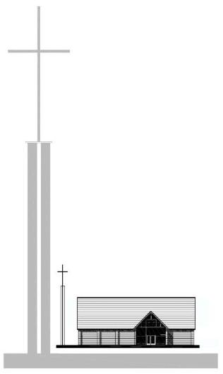
St. George’s Church - 2022
“Rejoice in our confident hope. Be patient in trouble, and keep on praying.”
Romans 12 v 12 (NLT)

St. George’s Church - 2022
“Rejoice in our confident hope. Be patient in trouble, and keep on praying.”
Romans 12 v 12 (NLT)

St. George’s Church - 2022
“Rejoice in our confident hope. Be patient in trouble, and keep on praying.”
Romans 12 v 12 (NLT)

St. George’s Church - 2022
“Rejoice in our confident hope. Be patient in trouble, and keep on praying.”
Romans 12 v 12 (NLT)

